**BULL’S HEAD**

**CHISLEHURST**

**CELEBRATION PACK**

The 18th Century Bull's Head Hotel is situated in the picturesque part of Chislehurst, centrally located for easily accessibility with 15 boutique bedrooms above our stunning function room, ‘The Maxwell’. We can accommodate from as few as 20 to 180 people making us an ideal venue for your special event! With ease we can cater for wedding ceremony and reception. Our dedicated Events Team Jayne, who has 20 years of experience hosting events at the Bull's Head, will be more than happy to assist you! You will be sure to have our undivided attention throughout the day by our fantastic events team.

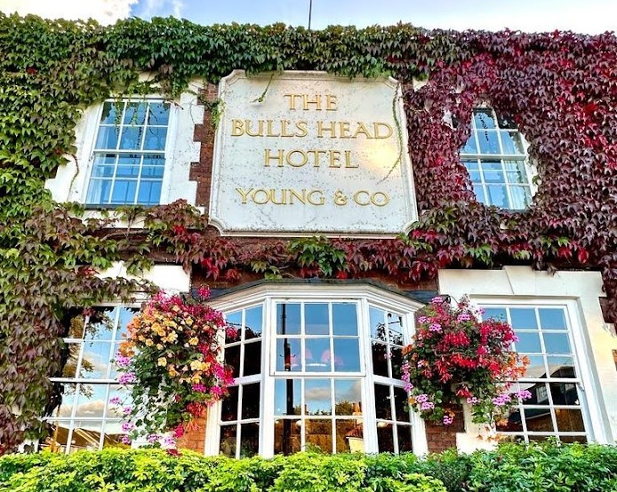

**THE MAXWELL**

A completely private space for you to enjoy your day the way you want to. You will have access to a private bar and access to a private terrace area, ideal for all events.

**ROOM HIRE CHARGES**

|  |  |  |  |  |  |  |  |  |  |  |  |  |
| --- | --- | --- | --- | --- | --- | --- | --- | --- | --- | --- | --- | --- |
|  | Jan | Feb | Mar | Apr | May | Jun | Jul | Aug | Sep | Oct | Nov | Dec |
| Mon | £300 | £300 | £300 | £400 | £400 | £500 | £500 | £500 | £500 | £400 | £400 | £500 |
| Tues | £300 | £300 | £300 | £400 | £400 | £500 | £500 | £500 | £500 | £400 | £400 | £500 |
| Wed | £300 | £300 | £300 | £400 | £400 | £500 | £500 | £500 | £500 | £400 | £400 | £500 |
| Thur | £300 | £300 | £500 | £500 | £500 | £500 | £500 | £500 | £500 | £500 | £500 | £500 |
| Fri | £500 | £500 | £500 | £600 | £600 | £750 | £750 | £750 | £750 | £600 | £600 | £750 |
| Sat | £650 | £650 | £650 | £750 | £800 | £1250 | £1250 | £1250 | £1250 | £750 | £750 | £1250 |
| Sun | £350 | £350 | £350 | £500 | £500 | £500 | £500 | £500 | £500 | £500 | £350 | £500 |

* Bank holiday Sunday or Monday £600
* We can also host your wedding ceremony here for an additional £300

(please note this is not the registrar fee)

**HOTEL ROOMS**

The Bull’s Head has 15 bedrooms, with a mixture of twin and double rooms available. Our Bridal Suite includes a four poster bed roll top bath, double shower and a traditional fireplace. All rooms have Free Wi-Fi, Flat screen TV, Nespresso coffee machines, Snack bars or mini bars, iron and ironing boards, Bramley natural botanic toiletries, hairdryers and much more. If you require any more information, then please contact the Rooms team; Amy or Carole.

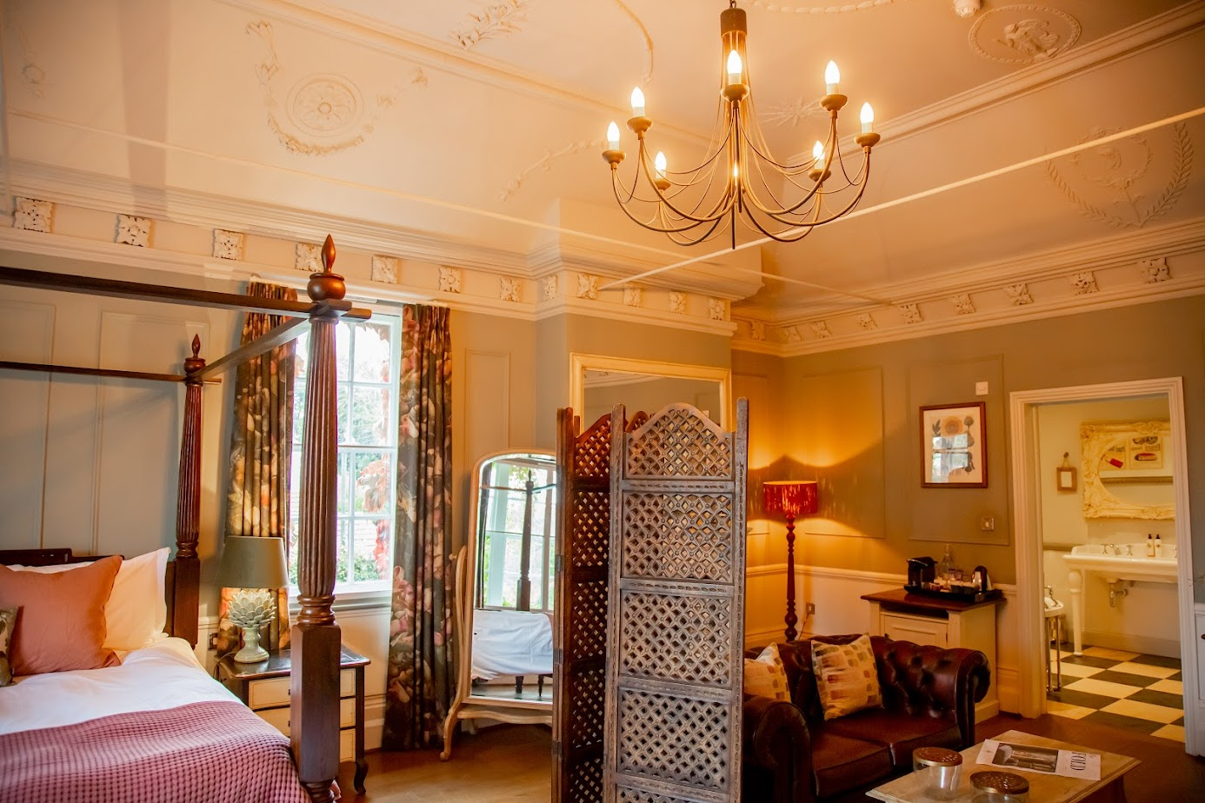

**Gold**

Prosecco reception - 2 glasses per guest

(Sparkling elder flower for non-alcoholic)

3 canapés per person

3 course Wedding Breakfast

Tea and coffee station

Nyetimber Champagne to toast

Evening Buffet

£175 per guest (min 30 people)

**Silver**

Arrival Drinks - 1 glass per guest

(Choice of Prosecco, Pimms or Bottled Beer or

Sparkling Elder-flower)

3 course Wedding Breakfast

Tea and coffee station

Paul Dangin et Fils Brut Champagne to toast

£125 per guest (min 30 people)

**Bronze**

Arrival Drink - 1 per guest

(Choice of Prosecco, Pimms or Bottled Beer

or Sparkling Elder-flower)

3 course Wedding Breakfast

Tea and coffee station

Prosecco toast

£75 per guest (min 20 people)

**DRINKS**

After the ceremony, smiles and possibly tears of joy, a drink is most certainly called for. Whether a glass of champagne, prosecco or a crafted cocktail - we can cater to your taste. The biggest draw to having your wedding in a pub - the range of drinks available. Our extensive wine list features wines from all over the globe, and together with our wide choice of beers and spirits we’ll ensure you and your guests never go thirsty.

Paul Dangin et Fils Brut Champagne - £50.50

Nyetimber Classic Cuvee - £65.50

Nyetimber Rose- £75.50

Veuve Clicquot Brut Yellow Label Champagne - £89.50

We allow for 6 glasses per bottle of Champagne or Prosecco

Please ask to see our full wine list or pop in

and sample our extensive list.

**SPRING/SUMMER**

April-September

***W*e request that you choose the same set menu for all your guests. We will of course cater for any vegetarians and special dietary requirements.**

***STARTERS***

Smoked salmon, avocado mousse, sourdough

Sundried tomato pesto, burrata, and crushed pistachio

Minestrone soup, sourdough

Classic prawn cocktail

***MAINS***

Corn fed chicken supreme, mashed potato, broccoli, chorizo sauce

Pan fried seasonal fish, crushed new potatoes, sundried tomatoes, pistachios and citrus

Vegetable wellington, veg trimmings

Choice of roast chicken, beef or pork, with all the trimmings

Chicken and mushroom pie, mash, seasonal vegetables

***DESSERT***

Champagne & berry posset, shortbread

Bramley apple tart, clotted cream

Lemon tart, blood orange sorbet

Chocolate ganache tart, torched orange

Cheesecake, honeycomb, ice cream

*£55 per person*

All menus are samples and subject to seasonal changes. We are happy to cater for any dietary requirements, please speak to us upon booking. Before you order your food and drink, please inform a member of staff if you have a food allergy or intolerance. Fish dishes may contain bones.

**AUTUMN/WINTER**

October-March

***W*e request that you choose the same set menu for all your guests. We will of course cater for any vegetarians and special dietary requirements.**

***STARTERS***

Pork, apple & leek scotch egg, plum ketchup

Smoked mackerel pate, fennel & apple salad, sourdough

Goats cheese tart, sundried tomatoes, caramelised onion

Butternut squash & sage soup, sage crisps, sourdough

***MAINS***

Choice of roast chicken, beef or pork, with all the trimmings

Salmon en croute, tenderstem broccoli, white wine cream

Heritage squash & mushroom wellington, cabbage and leeks, vegetable jus

Pan fried duck breast, horseradish mash, berry compote, orange jus

Steak and ale pie, mash, seasonal vegetables

***DESSERT***

Chocolate brownie, chocolate sauce, vanilla ice cream

Sticky toffee pudding, toffee sauce, salted caramel ice cream

Winter berry cheesecake

Dark chocolate mousse, toasted hazelnut praline

Apple and cinnamon crumble, and custard

*£55 per person*

All menus are samples and subject to seasonal changes. We are happy to cater for any dietary requirements, please speak to us upon booking. Before you order your food and drink, please inform a member of staff if you have a food allergy or intolerance. Fish dishes may contain bones.

**LIGHT LUNCH BUFFET**

Selection of assorted sandwiches

Mini sausage rolls

Mini quiche

Scotch egg

Triple cooked chips

Tea and coffee

Nibbles

*£17 per person*

**ALL DAY BUFFET**

Selection of assorted sandwiches

Mini sausage rolls

Selection of Crostini

Mini quiche

Chicken and ham terrine

Scotch eggs

Chicken goujons

Triple cooked chips

Tea and coffee

Nibbles

*£24 per person*

**SOMETHING EXTRA**

Platters of sandwiches for 10 people £70

Chefs choice of quiche, for 10 people £30

Selection of Pastries £4pp

Scones, served with clotted cream and jam £3.75pp

Mini Victoria sponge for 20 people £40

Jugs of fruit juices, £10 per jug

**CANAPES**

Smoked salmon Bilinis

Chicken and ham terrine

Braised Ox Cheek Yorkshire Puddings

A selection of crostini

Caprese skewer

*£2.50 per canape*

**PLATTERS**

*All platters serve 10 people*

Cheese burgers, served with ketchup, mayo, lettuce and chips

*£70 per platter*

Crispy chicken burgers, served with katsu curry sauce, lettuce and chips

*£90 per platter*

Plant burgers, served with vegan cheese, ketchup and vegan mayo

*£85 per platter*

Fish and chip buckets, served with tartar sauce

*£60 per platter*

Bacon rolls

*£60 per platter*

Sausage in a roll

*£60 per platter*

**BBQ PLATTER**

Pork ribs

Chicken wings

Pulled pork and ox cheek bap

Corn on the cob

Coleslaw

Chips

Vegetables

Bread and butter

Tea and coffee

*£35 per person*

**PLOUGHMAN’S PLATTER**

Ham and chicken terrine

Cheddar

Blue cheese

Sausage roll

Scotch eggs

Bread and butter

Pickles

*£180 per platter, serves 10*

**CAMEMBERT PLATTER**

Honey and almond camembert

Rosemary garlic camembert

Basil pesto camembert

Bread

*£150 per platter, serves 10*

**CHILDREN’S BUFFET**

Sandwiches

Chicken goujons

Crudities

Chips

Mac and cheese

*£15 per child*

**CHILDREN’S MENU**

***STARTERS***

Hummus and crudities

Garlic bread

Soup of the day

***MAINS***

Chicken goujons, chips, beans or peas

Sausage and mash, beans or peas

Tomato pasta

Roast dinner (only available when adults order this)

***DESSERT***

Chocolate brownie and ice cream

Selection of ice cream

Fruit salad

*£18 per head*